# Setting up Eclipse IDE for Python Development

These instructions assume that you have already installed “Python” as per the document “Install Python and Run demo.py”, and successfully run demo.py from the command line. If not, please work through that document before this one.

1. **Download and Install Eclipse IDE for Java Developers**

You might have already installed this on your computer to do the “Big Data Processing” week 3 lab, where we built and ran a simple MapReduce program (to count how many times each word appears in an input file). If not…

Go to:

<http://www.eclipse.org/downloads/packages/release/kepler/sr1/eclipse-ide-java-developers>

I clicked on “Download 64-bit” and then “Download” on the next page.

I ran the installer, but it took me to a web page complaining that I didn’t have the right version of Java installed. It wanted me to install Java 1.8.0 (64 Bit), so I had to stop and do that, first.

It gave me a link to download JDK 12, so I followed that:

<https://www.oracle.com/technetwork/java/javase/downloads/jdk12-downloads-5295953.html>

Click on the radio button to “Accept” the licence agreement, then download the correct installer for your system. I chose the Windows “exe” installer.

Run the Java installer, install it in the default location with the default options.

Re-run the “Eclipse” installer. It should be happier now.

It will give you this window:

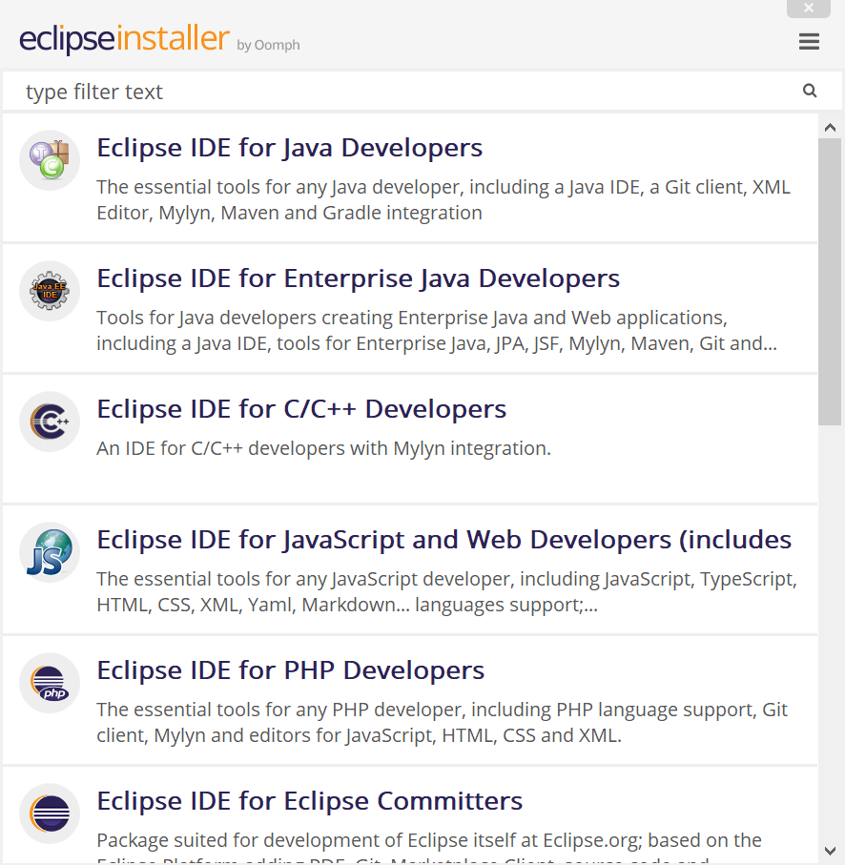

Choose “Eclipse IDE for Java Developers”.

Accept the options and hit “Install”. Hit “Accept”. Choose “Remember accepted licenses” and “Accept”.

It will ask you if you trust two “Eclipse Foundation” certificates. Hit “Select All” then “Accept selected”.

When it finishes installing, hit “Launch”!

In the next window, allow it to use the default “Workspace” and hit “Launch” again.

1. **Set up the Eclipse IDE for Python Development**

In the “Welcome” window, choose “Launch the Eclipse Marketplace”

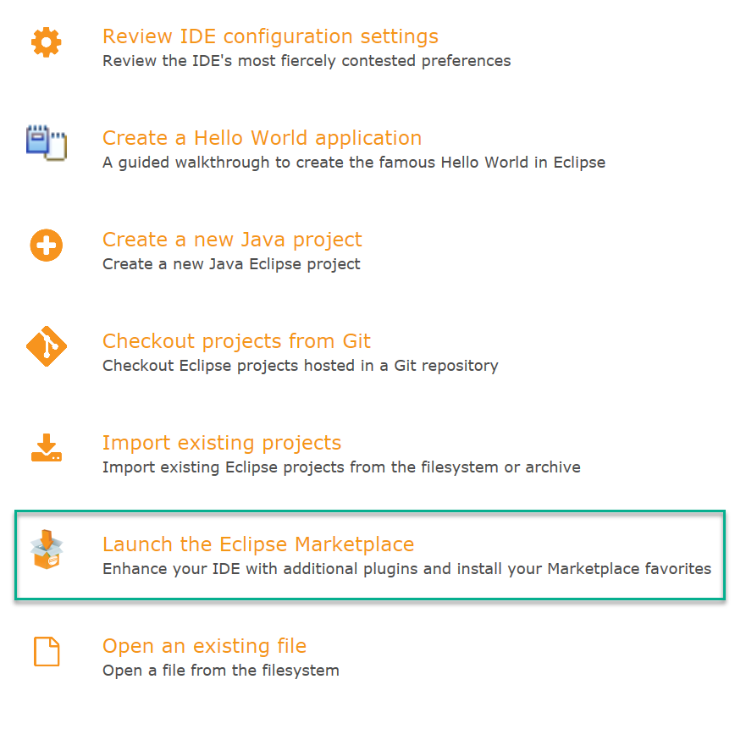

In the “Eclipse Marketplace” window, search for “pydev” in the “Find:” text box, and then, when you find it at the top of the results, hit “Install”:

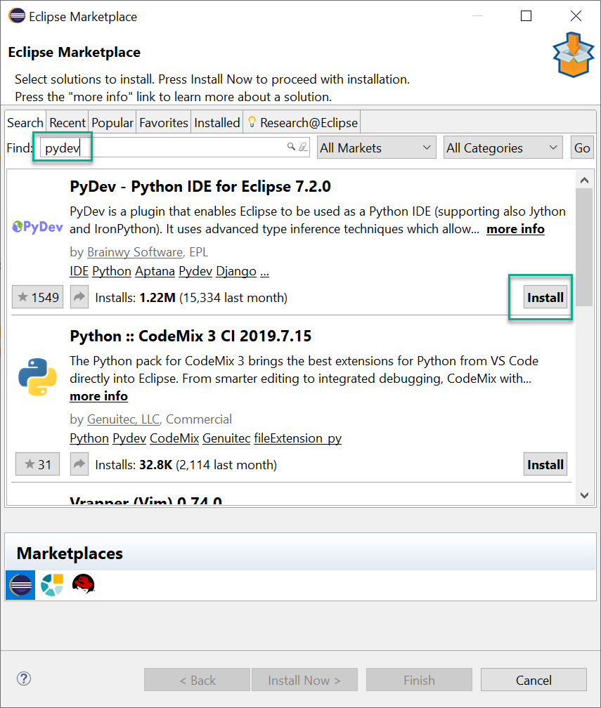

It will think about it for a few seconds, then ask you to confirm which features you’re installing. Accept the default (which is to install them all) and hit “Confirm >”

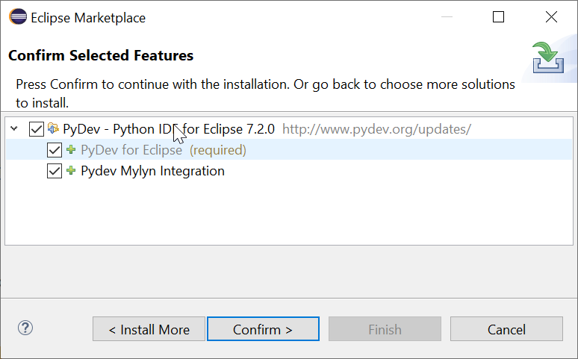

Accept the terms of the license and then hit “Finish”:

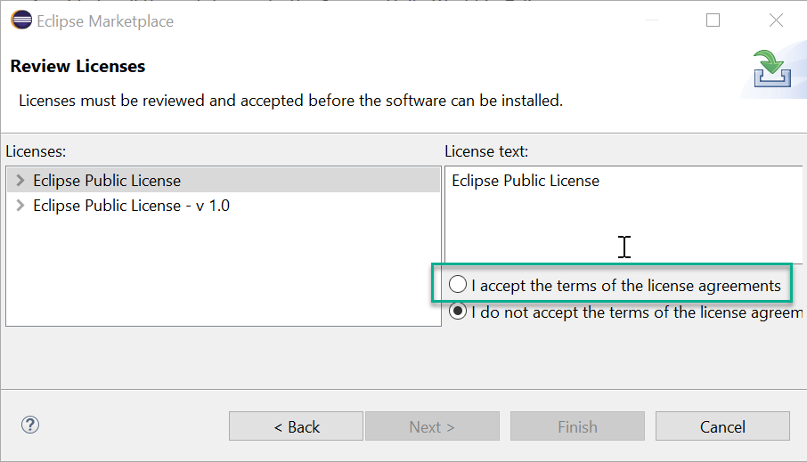

It will go back to the “Welcome” screen, and if you look carefully in the bottom right, you’ll see messages to say that it’s “Installing Software”. Then, it’ll ask if you want to restart to apply the changes:

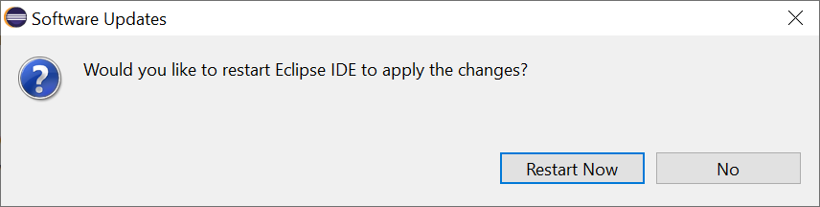

Choose “Restart Now”.

Next, you need to tell the Eclipse IDE where to find the “python” interpreter you installed.

(Instructions adapted from <https://www.vogella.com/tutorials/Python/article.html>)

In Eclipse, choose Window -> Preferences, then in the “listtree” on the left, drill into PyDev -> Interpreters and select “Python Interpreter”:

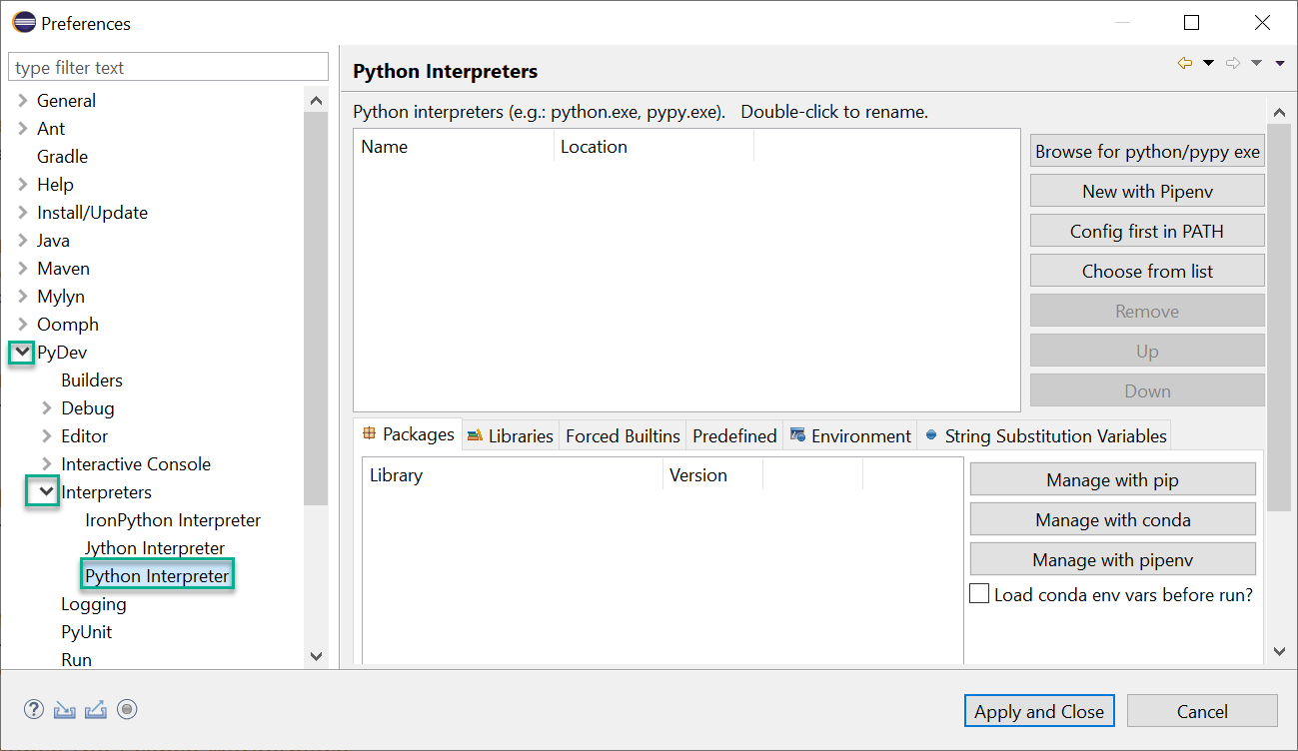

This is where you must tell Eclipse where you installed “Python” previously (see “Install Python and Run demo.py”)

For me, it was in C:\Users\User\AppData\Local\Programs\Python\Python37, there was a “python.exe” in there. If you can’t find it on your system, try asking Windows File Explorer to do a “search” for “Python37” on C: drive. If you installed Python 3.7, you should find a folder by that name, with “python.exe” inside.

Choose “Browse for python/pype exe” and find where your “python.exe” is, select it, and choose “Open”.

It’ll ask you to give an “Interpreter Name”. The default is “python” but I called it “python37” so that I’d remember it’s version 3.7, in case I need to install python 2.7 as well, for this project, or any other work.

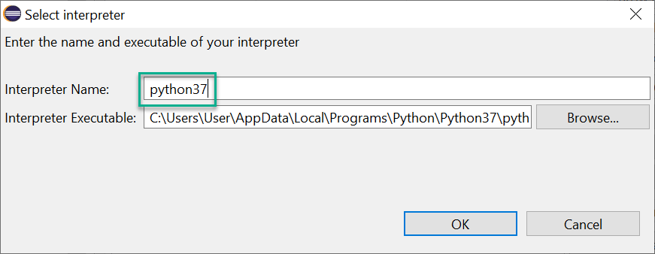

Press “OK”:

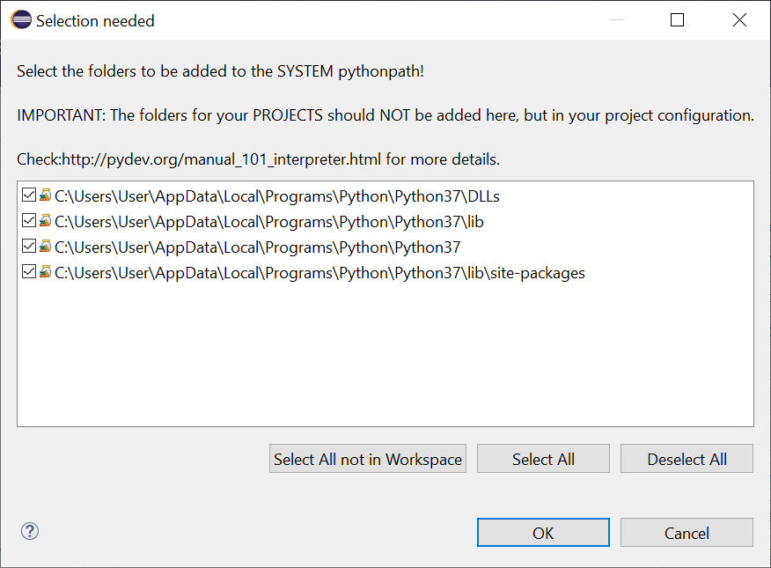

Make sure all the paths are selected (they should be, by default) and then press “OK”.

Finally, back in the “Preferences” Window, choose “Apply and Close”.

At this point, it thought about it for a while, then took me back to the “Welcome” page. I was asked by Windows Firewall if it was OK for “eclipse” to connect to my “private networks”, and I chose “Allow access”:

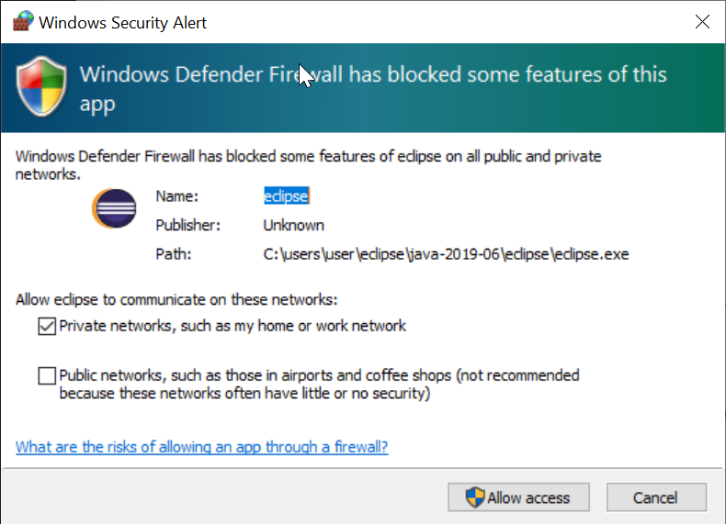

1. **Run “demo.py” within the Ecipse IDE**

Back in the main Eclipse IDE window (with the “Welcome” tab) choose File -> New -> Project…

You will see the “New Project” wizard:

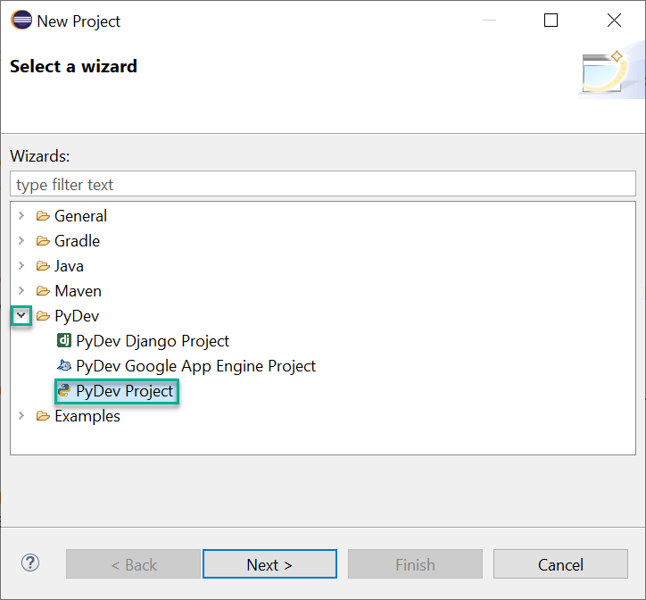

Drill into “PyDev” and choose “PyDev Project” then “Next >”

Fill in a “Project Name”, I chose “Satellite Intelligence Demo 1”. I accepted all other defaults (e.g. to use “python37” as the interpreter, and the default location to store the project) and then hit “Finish”:

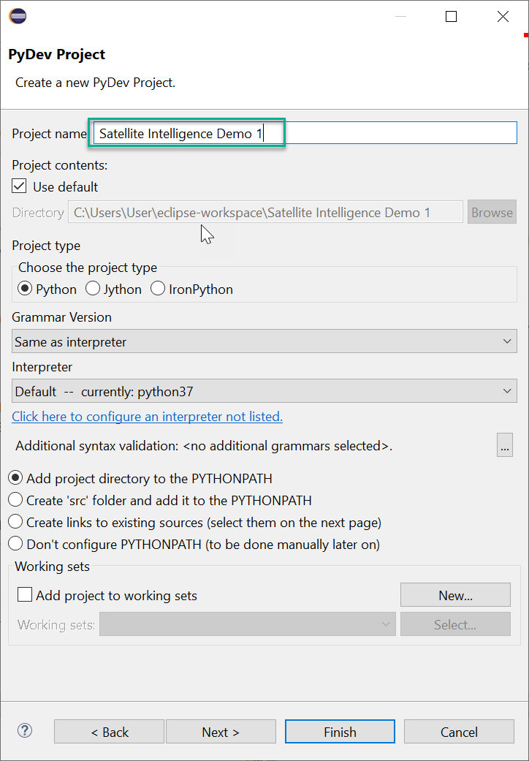

When it asks, hit “Open Perspective” to open this new project in the “PyDev” perspective:

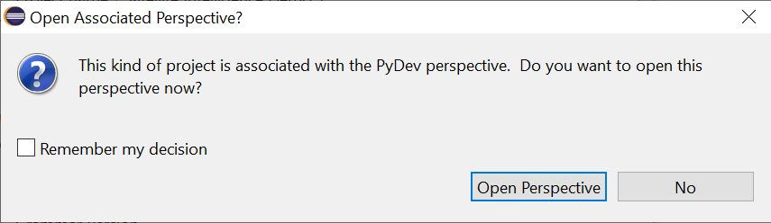

Nothing seemed to happen… But there is a tiny button under “File” which opens up the “PyDev” stuff we’re looking for. Press it:

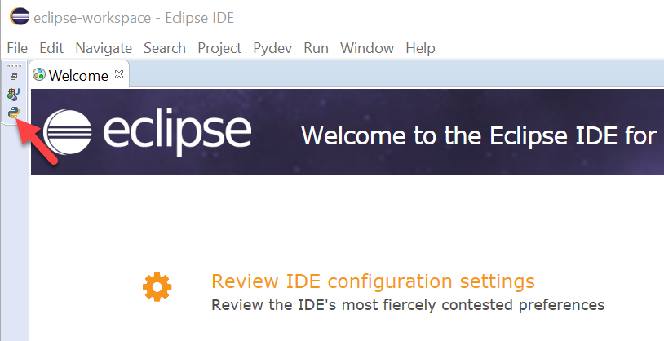

Some windows will open them up. Adjust their sizes to see them properly, if necessary, and you can make them look like this:

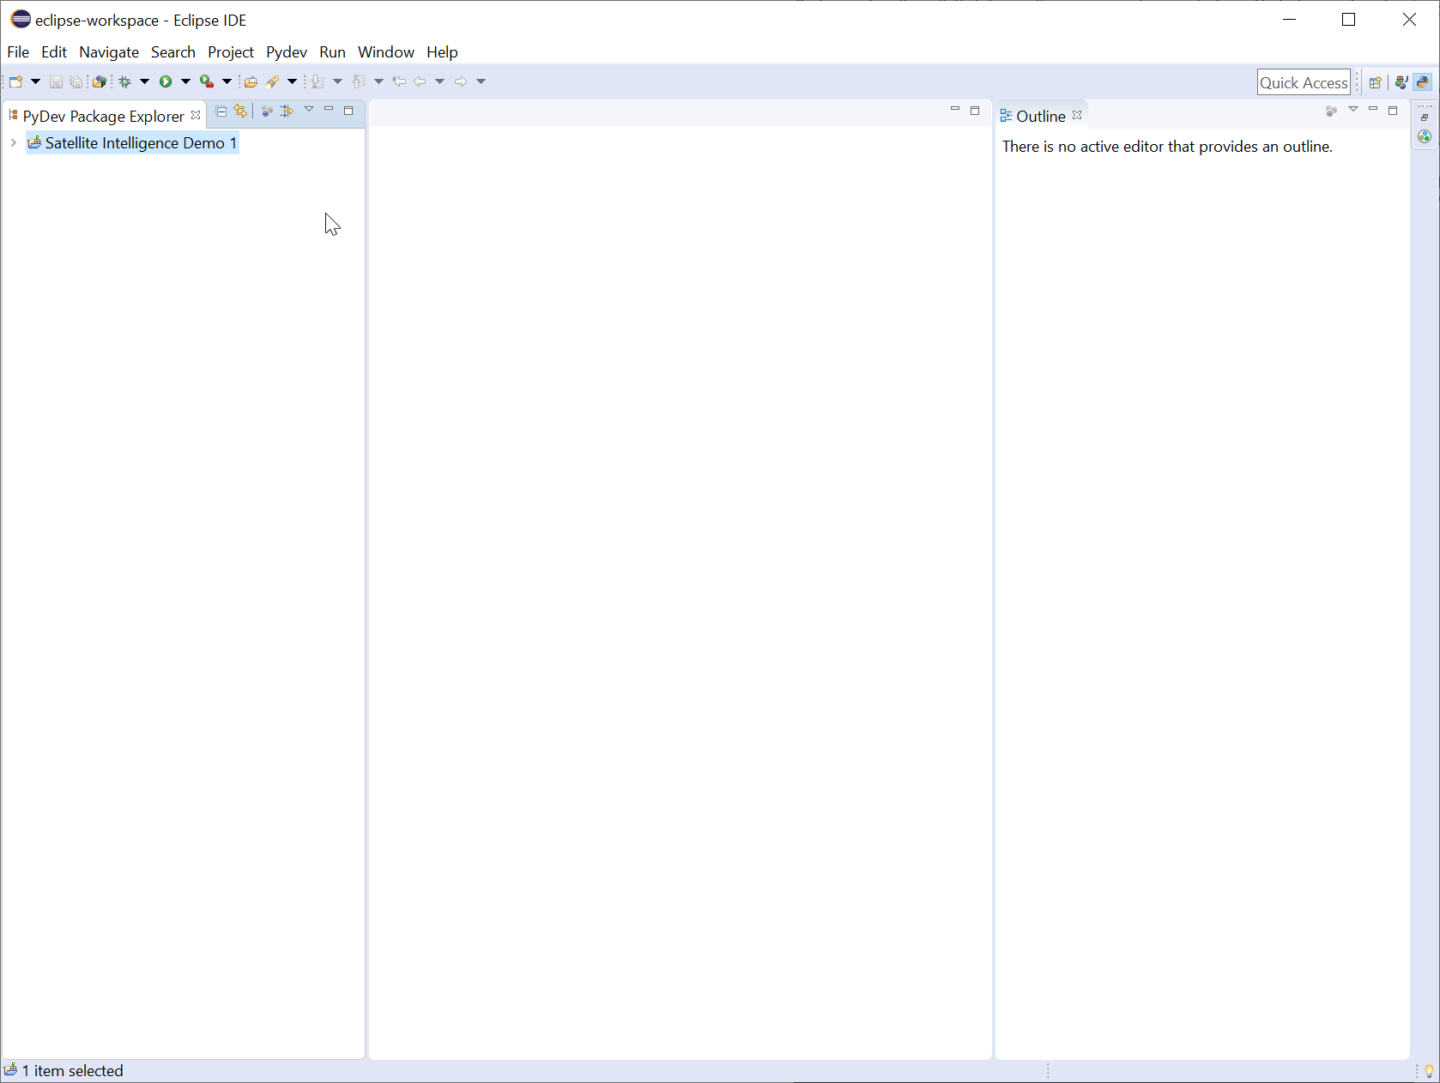

In the “PyDev Package Explorer”, right-click on your project -> New -> PyDev Module.

Leave “Package” blank, but for the name, say “demo1”. Then press “Finish”.

It will offer to create this file from a Template. We’re just going to copy-and-paste the code in from the original, so just choose the “<Empty>” template and “OK”:

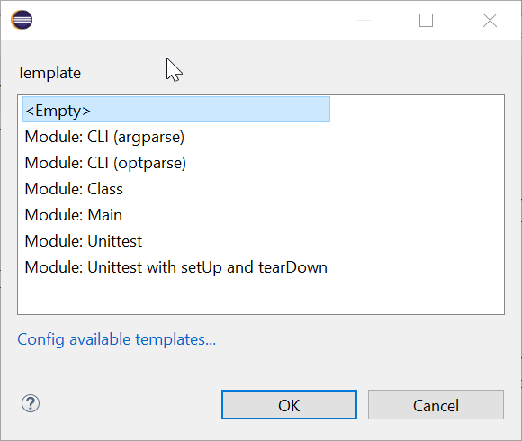

You may also be prompted for some default behaviours for PyDev, I just accepted the defaults and pressed OK:

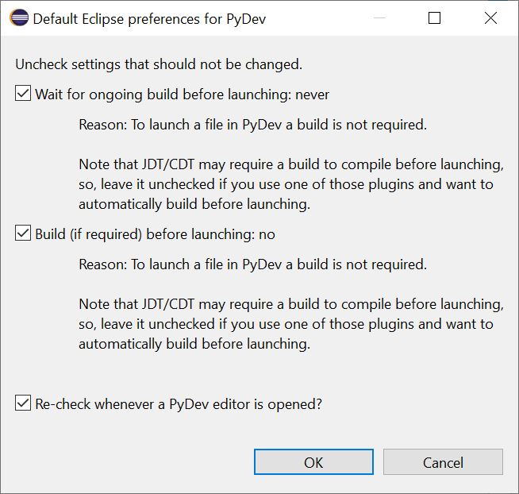

You should now have a “demo1.py” file that is mostly empty, except for some header comments to say when you created it.

Find the original “demo.py” from the “phase 1 data release”. Open it with “notepad” and copy the contents to your “clipboard”. Paste them into the window where we’re editing “demo1.py” and hit Ctrl-S to save:

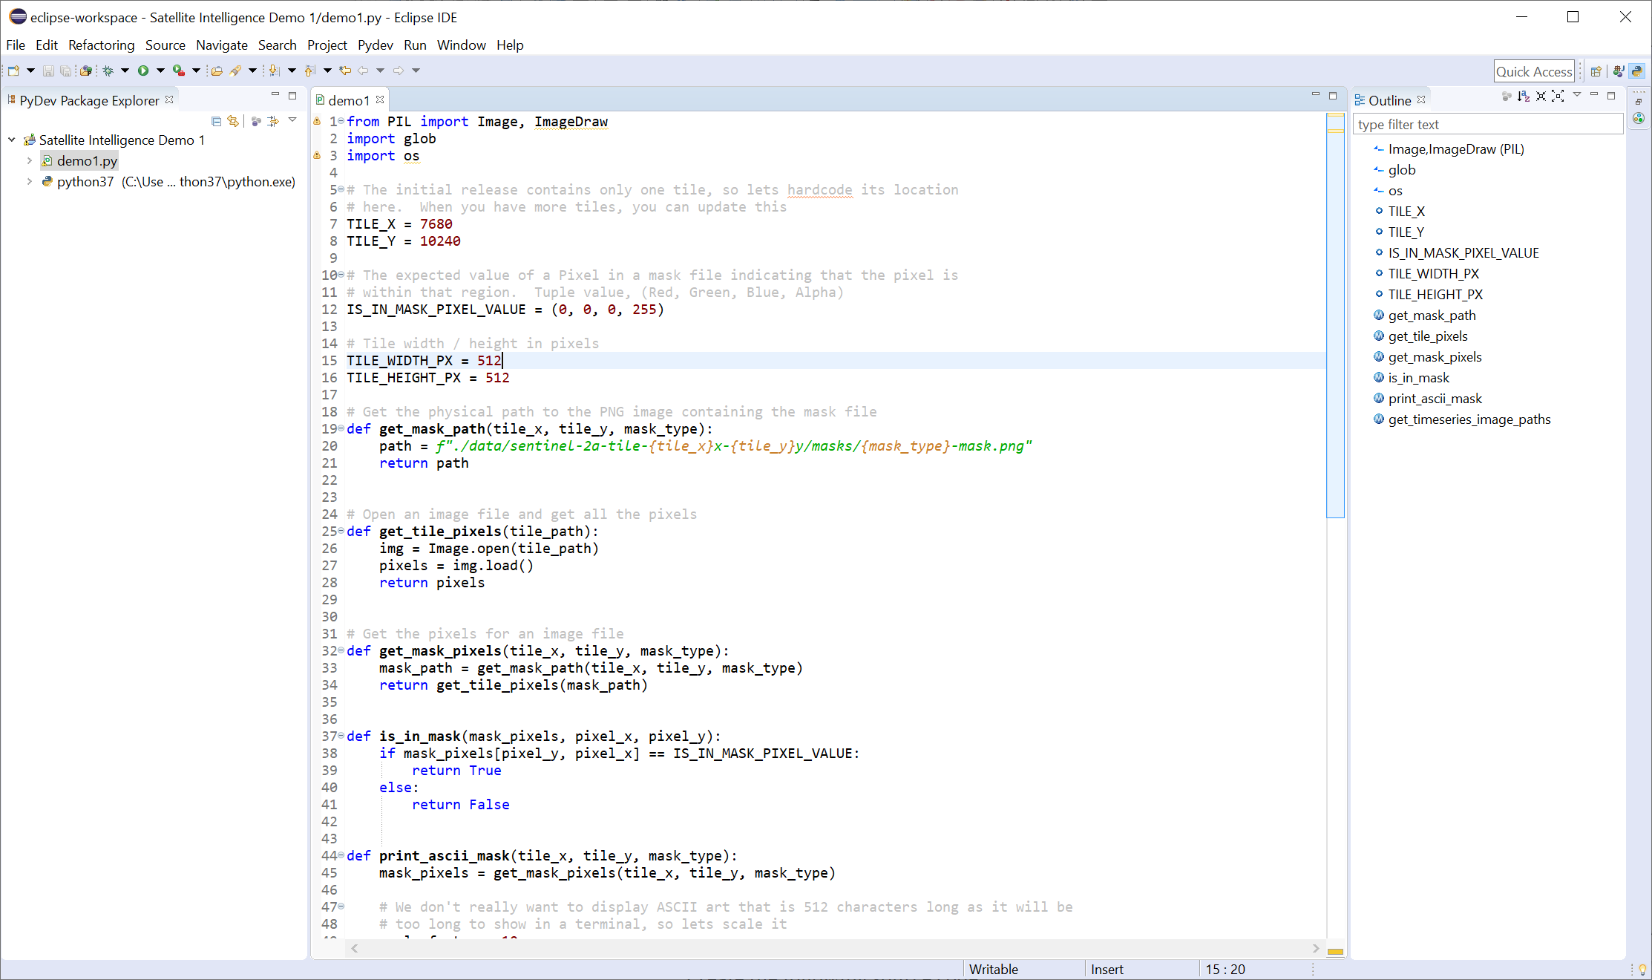

Before we run the program, we need to make sure it can find our data!

The demo program just says to find a “Data” directory in the current working directory. But by default, Eclipse will assume the current working directory should be the directory where we created the Eclipse project. You almost certainly saved the “Data” folder somewhere else!

In the “Explorer”, right-click on “demo1.py” -> Run As -> Run Configurations…

Choose the “Arguments” tab, and look for the place it says “Working Directory”:

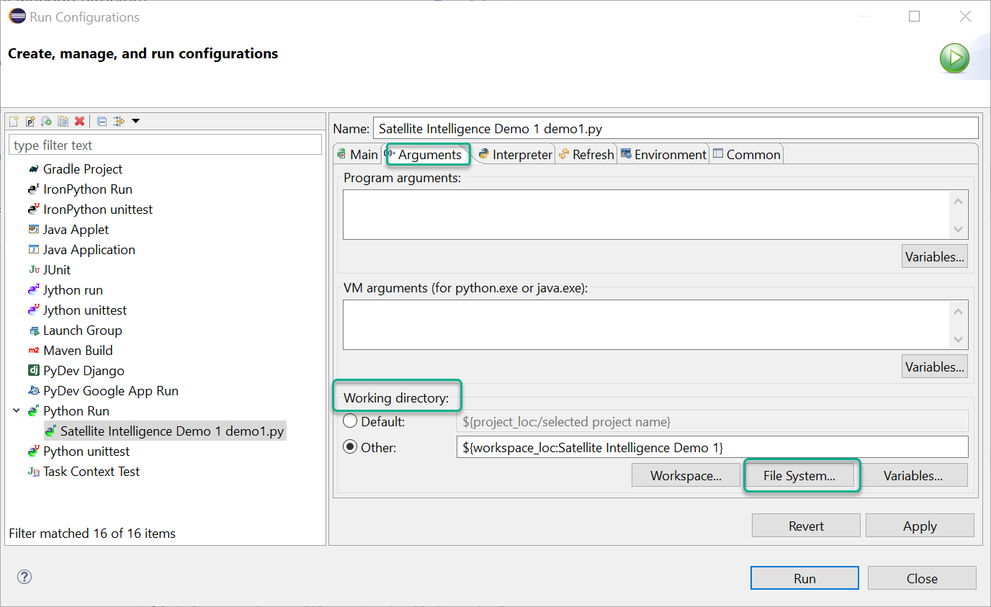

Choose “File System…” and browse into your “phase-01” directory from where you unpacked the data from the Datathon. Choose “Select Folder”.

NOTE: You want to “Select Folder” from within “phase-01”, where you can see a “Data” directory. You do not want to choose the “Data” directory itself.

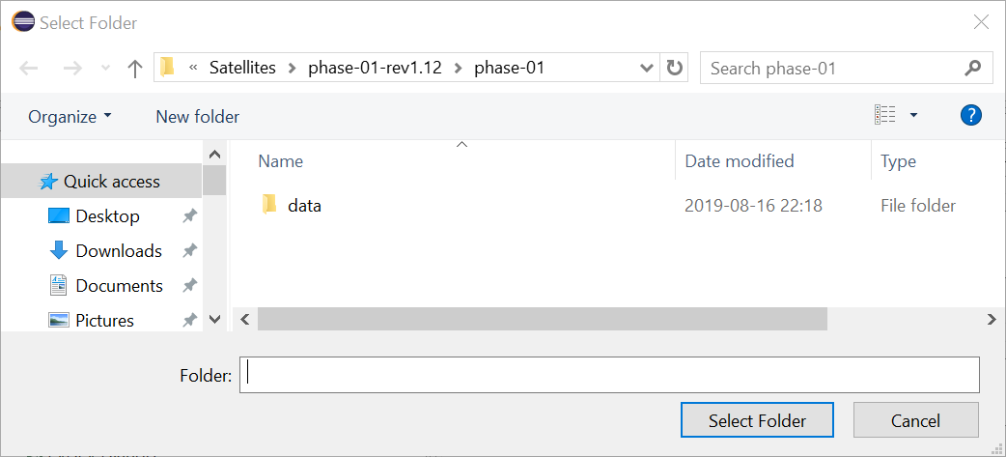

The “Working Directory” should now be the place where we can find the “Data”. Choose “Run”:

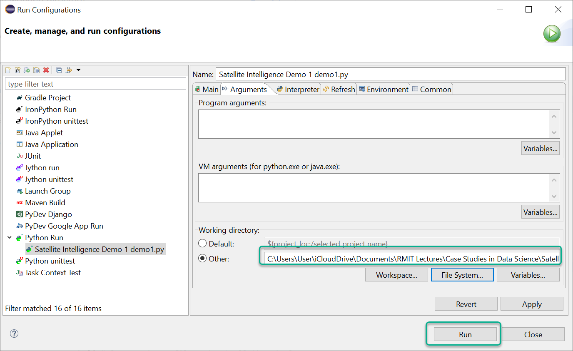

When you run the program, you should see the “ASCII” representation of the map in the “Console” as a bunch of “X” characters:

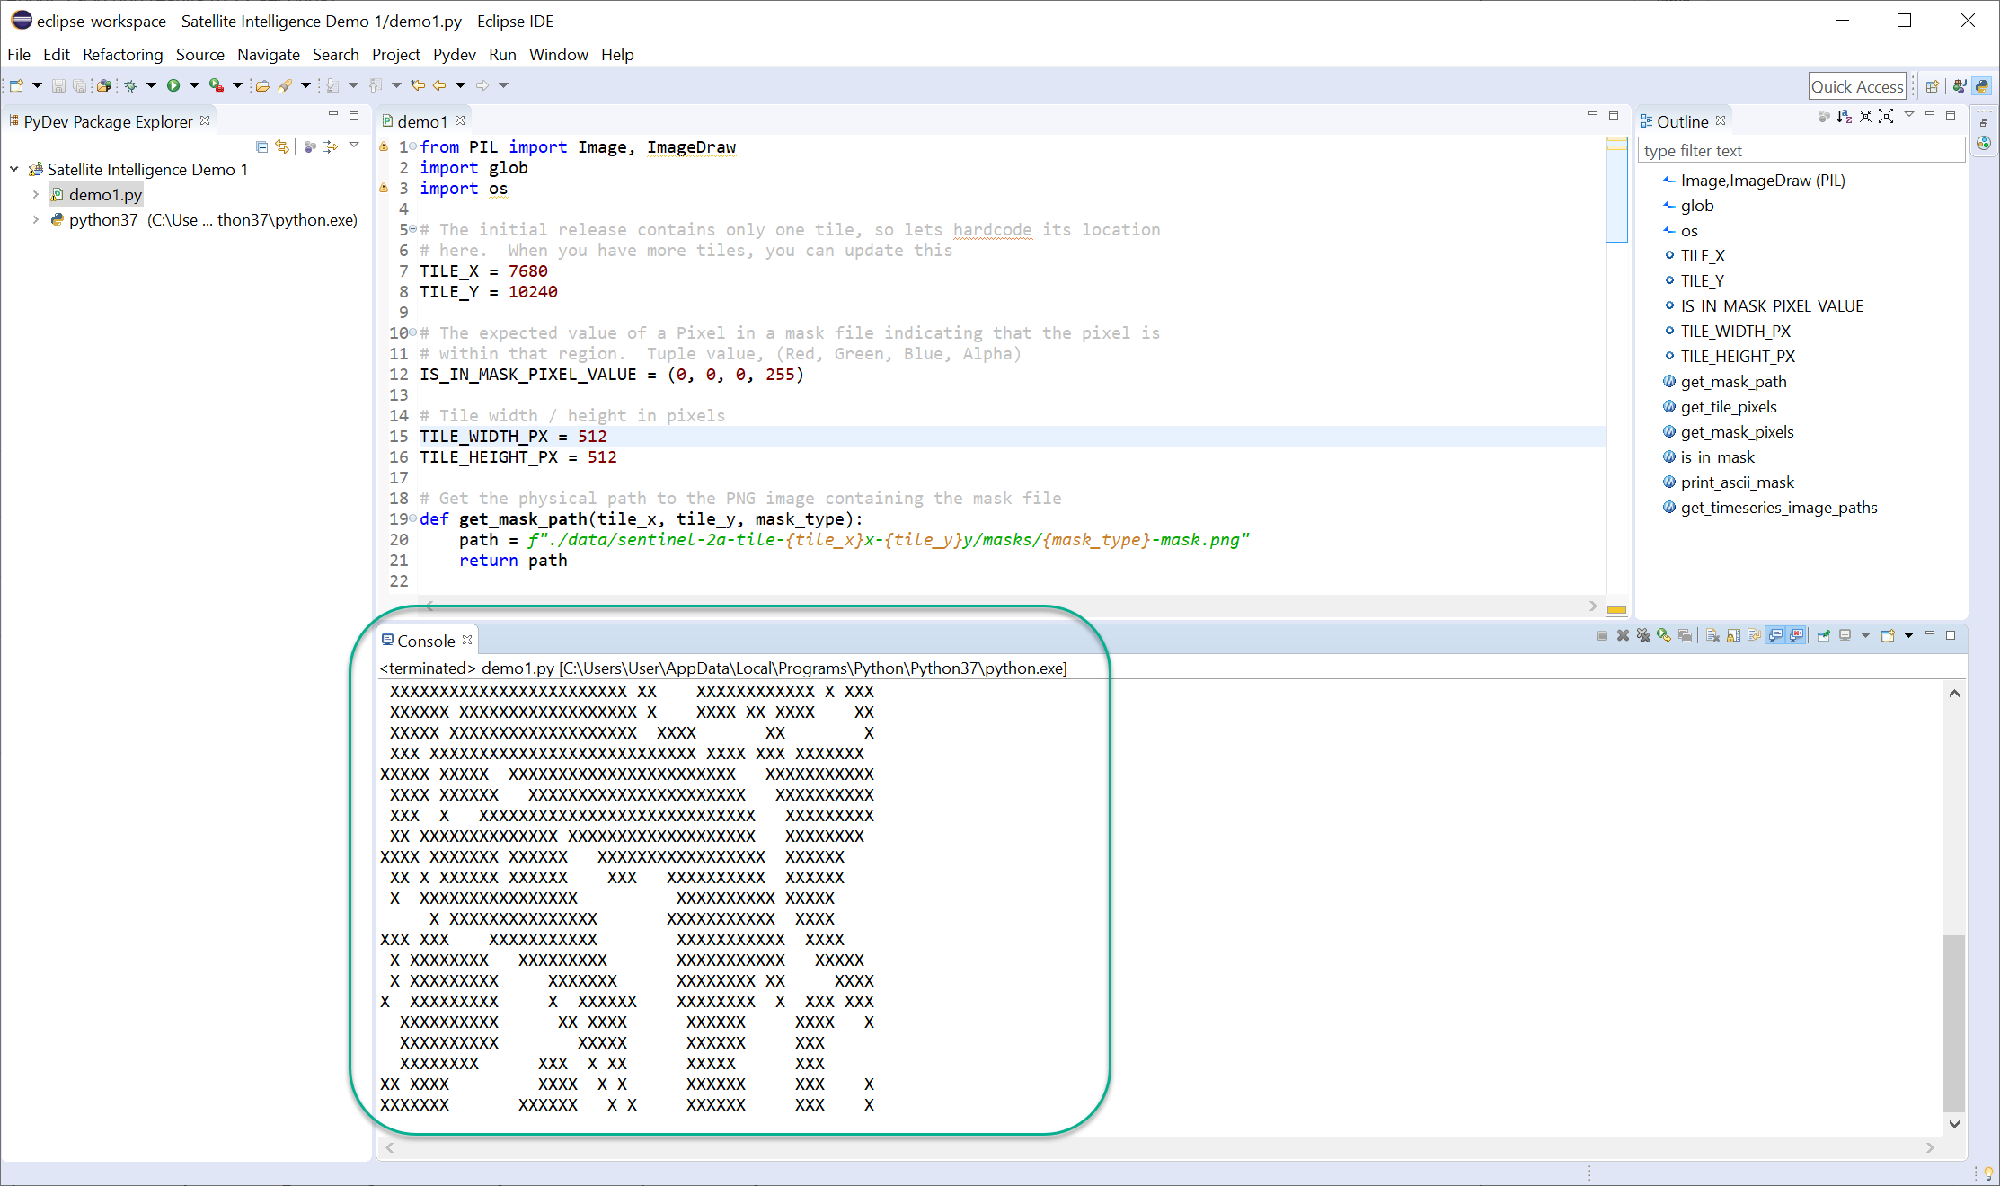

Congratulations, it worked!

To run again, you don’t need to go to “Run Configurations…” and tell it the working directory each time. Just right-click on demo1.py -> Run As -> 1 Python Run. It’ll remember!